

Streaming State Management



March 24, 2024

COGNIZANT



**Abstract:**

* The "Streaming State Management" project explores the utilization of PySpark's streaming capabilities to manage state effectively across diverse data processing tasks in real-time. By implementing sessionization, stateful aggregation, and real-time analytics, the project aims to showcase the practical application of streaming state management techniques across various operational domains. Through a dataset capturing employee activities—ranging from logins to clicks and logouts, the project demonstrates its ability to dynamically track and analyze employee sessions. Processing streaming data streams enables the project to provide real-time insights into session counts and cumulative actions, thereby aligning seamlessly with its overarching objectives.
* In practical scenarios, the project showcases how streaming state management optimizes employee productivity by monitoring real-time user activities across digital platforms. For example, by analyzing live examples of employee login/logout events and application usage patterns, the project illustrates the proactive identification of workflow bottlenecks and opportunities for process optimization. These real-
* world applications emphasize the direct relevance of streaming state management in enhancing operational efficiency and enabling proactive decision-making in today's dynamic business environments.
* Moreover, in the realm of e-commerce, streaming state management enables platforms to track and analyze user interactions in real-time. By processing streaming data streams of user clicks, searches, and purchases, e-commerce companies can provide personalized recommendations, targeted advertising, and dynamic pricing strategies, thereby enhancing the overall customer experience and driving business growth. Streaming technology plays a crucial role in enabling real-time data processing and analysis, empowering organizations to make informed decisions and stay competitive in today's fast-paced digital landscape.

**TABLE OF CONTENTS**

**Introduction**

* Overview of Streaming State Management
* Project Objectives

**Background**

* Introduction to Streaming Data Processing
* Understanding Databricks for Real-time Analytics
* Key Concepts of Streaming State Management

**Data Preparation**

* Description of Input Dataset
* Data Ingestion Techniques in Databricks
* Data Cleaning and Preprocessing in Databricks

**Implementation in Databricks**

* Setting Up Databricks Environment
* Reading and Processing Streaming Data in Databricks
* Output of the code

**Real-world Examples**

* Application of Streaming State Management in Employee Tracking
* Use Cases in Various Industries

**Conclusion**

* Summary of Project Findings

**Overview of Streaming State Management for User Session Tracking**

* Streaming state management is a critical component in real-time data processing systems, particularly in scenarios involving employee session tracking. In the context of this project, streaming state management refers to the process of efficiently managing and maintaining the state of employee sessions as they occur in real-time. This involves tracking and analyzing various user activities such as logins, clicks, and logouts dynamically, and deriving actionable insights from the streaming data.
* The primary objective of streaming state management in this project is to enable organizations to monitor and optimize employee productivity by gaining immediate visibility into their digital interactions. By leveraging streaming technologies, organizations can process and analyze employee session data in real-time, allowing for proactive identification of workflow bottlenecks, optimization of processes, and timely interventions.
* Key components of streaming state management include sessionization, which involves grouping user activities into sessions based on predefined criteria such as time intervals or user interactions, and stateful aggregation, which entails maintaining and updating the state of employee sessions dynamically as new data arrives. These techniques enable organizations to track session counts, analyze cumulative actions, and visualize real-time insights to drive informed decision-making.
* Through the implementation of streaming state management techniques in the Databricks environment, this project aims to demonstrate the practical application and significance of real-time session tracking in enhancing operational efficiency, improving user experiences, and driving business growth. By providing a comprehensive overview of streaming state management specifically tailored for employee session tracking, this project seeks to contribute to the broader understanding and adoption of real-time data processing technologies in organizational settings.

**Project Objectives**

* **Real-time User Session Tracking**: My objective is to implement a system for real-time tracking and analysis of user sessions based on streaming data. I will utilize PySpark and Databricks to process the input dataset capturing user activities such as logins, clicks, and logouts, and derive actionable insights in real-time.
* **Sessionization and State Management**: I aim to develop mechanisms for sessionization and stateful aggregation to group user activities into sessions and maintain the state of user sessions dynamically. I will implement techniques to handle streaming data efficiently and ensure accurate tracking of session counts and cumulative actions.
* **Dynamic Visualization of Insights**: My goal is to enable dynamic visualization of real-time insights derived from user session data. I will utilize data visualization techniques to present session counts, user interactions, and other key metrics in a visually intuitive manner, facilitating quick decision-making and proactive interventions.
* **Demonstration of Real-world Applications**: My objective is to showcase the practical applications of streaming state management techniques in user session tracking across various industries and use cases. I will provide real-world examples and scenarios demonstrating how real-time insights derived from user session data can drive operational efficiency, enhance user experiences, and enable informed decision-making.

**Introduction to Streaming Data Processing**

* In the realm of data processing, batch processing has long been a cornerstone method. Batch processing involves collecting, storing, and processing data in predefined, fixed-size batches. It's an effective approach when immediate analysis or response isn't necessary, as data is accumulated over time before processing occurs.
* However, the landscape of data processing is evolving, prompting the emergence of streaming data processing. Unlike batch processing, streaming data processing involves analyzing data in real-time as it's generated, offering immediate insights and enabling dynamic responses to changing conditions.
* The transition from batch to stream processing is motivated by the need for timelier insights and more responsive systems. With batch processing, there's typically a delay between data collection and analysis, whereas streaming data processing allows for instantaneous analysis and action as data flows through the system.
* For example, in an e-commerce setting, batch processing might be used to analyze sales trends over a month, whereas streaming data processing could provide real-time updates on website traffic, enabling immediate adjustments to marketing strategies or inventory management.
* This shift towards streaming data processing reflects the growing demand for agile, data-driven decision-making and underscores the importance of real-time insights in today's fast-paced business environment.

**Understanding Databricks for Real-time Analytics**

* Databricks is a powerful platform that enables organizations to harness the full potential of real-time analytics. Built on top of Apache Spark, Databricks provides a unified analytics platform that seamlessly integrates data engineering, data science, and machine learning capabilities, making it ideal for processing and analyzing streaming data in real-time.
* One of the key features of Databricks is its ability to scale seamlessly, allowing organizations to process large volumes of streaming data efficiently. By leveraging distributed computing capabilities, Databricks can handle massive datasets and perform complex analytics tasks in real-time, enabling organizations to derive timely insights from their streaming data streams.
* Another advantage of Databricks is its ease of use and flexibility. With its intuitive user interface and support for various programming languages such as Python, Scala, and SQL, Databricks empowers data engineers and data scientists to collaborate seamlessly and build sophisticated real-time analytics solutions without the need for specialized expertise.
* Furthermore, Databricks offers built-in support for streaming data processing, providing a range of features and functionalities to simplify the development and deployment of real-time analytics pipelines. From data ingestion and transformation to model training and deployment, Databricks streamlines the end-to-end process of building and operationalizing real-time analytics solutions.
* Overall, Databricks is a comprehensive platform for real-time analytics, offering scalability, flexibility, and ease of use to organizations looking to derive actionable insights from their streaming data streams. With its robust features and capabilities, Databricks empowers organizations to unlock the full potential of real-time analytics and drive business innovation.

**Key Concepts of Streaming State Management**

In the domain of streaming data processing, effective state management is essential for maintaining and tracking the state of data as it flows through the system. Here are the key concepts of streaming state management:

**1. Stateful Processing:** Unlike traditional batch processing, where each record is processed independently, stateful processing involves maintaining and updating state information across multiple records or events. This enables the system to retain context and continuity between data elements, facilitating complex analytics and aggregation tasks.

**2. Sessionization:** Sessionization is the process of grouping related events or activities into sessions based on predefined criteria such as time intervals or user interactions. In the context of user session tracking, sessionization enables the system to identify and track individual user sessions, allowing for analysis of session duration, frequency, and behavior patterns.

**3. Windowing:** Windowing is a technique used in streaming data processing to segment the data stream into discrete time intervals or "windows" for analysis. Different types of windows, such as tumbling, sliding, and session windows, allow for flexible aggregation and processing of data within specific time boundaries, enabling real-time analytics and insights generation.

**4. Watermarking:** Watermarking is a mechanism used to handle event time in streaming data processing. It allows the system to track the progress of event time and handle late-arriving data by defining a threshold beyond which older data is considered irrelevant. This ensures consistency and accuracy in state management, especially in the presence of delayed or out-of-order data.

**5. Approximate State Management:** In scenarios where maintaining exact state information is impractical or resource-intensive, approximate state management techniques such as probabilistic data structures or sampling algorithms can be employed. These techniques provide efficient estimations of state information, enabling scalable processing of large-scale streaming data streams.

**Description of Input Dataset**

The input dataset for this project consists of timestamped records representing employee activities such as logins, logouts, and other interactions within a system. Each record contains the following fields:

**1. Timestamp:** A timestamp indicating the date and time when the activity occurred. This field is of type `TimestampType()` in the dataset.

**2. User ID:** An integer identifier representing the employee who performed the activity. This field is of type `IntegerType()` in the dataset.

**3. Action:** A string indicating the type of activity performed by the employee, such as "login", "logout", or other interactions. This field is of type `StringType()` in the dataset.

The dataset is structured using a schema defined with the following fields:

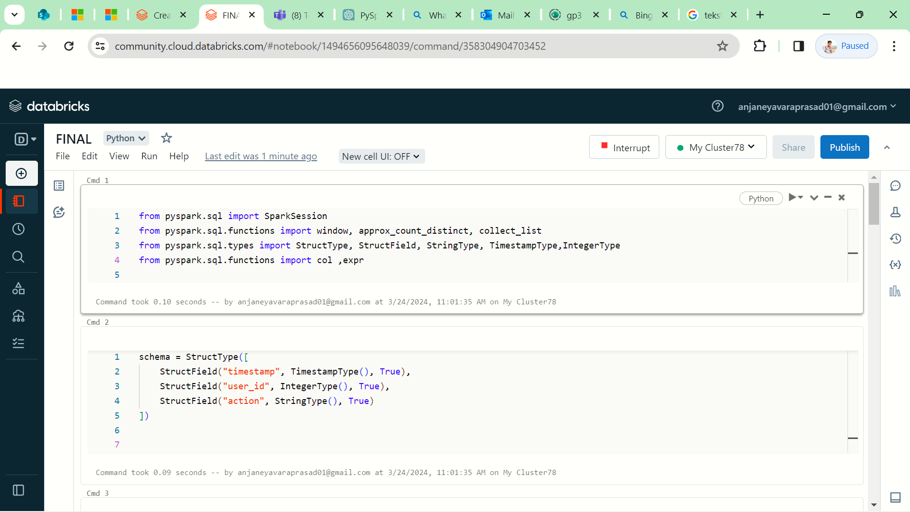

**Data Ingestion Techniques in Databricks**

In Databricks, there are several techniques for ingesting data from various sources into your environment for analysis. Here's an overview of data ingestion techniques commonly used in Databricks:

1. **Databricks File System (DBFS):** DBFS is a distributed file system installed on Databricks clusters. You can use DBFS to store and access files, including data files, scripts, and libraries. You can upload data files directly to DBFS through the Databricks Workspace UI or programmatically using Databricks APIs.
2. **Apache Spark APIs:** Databricks provides native integration with Apache Spark, allowing you to use Spark APIs to read data from various file formats and sources. You can use DataFrame APIs like **spark.read** to read data from sources.

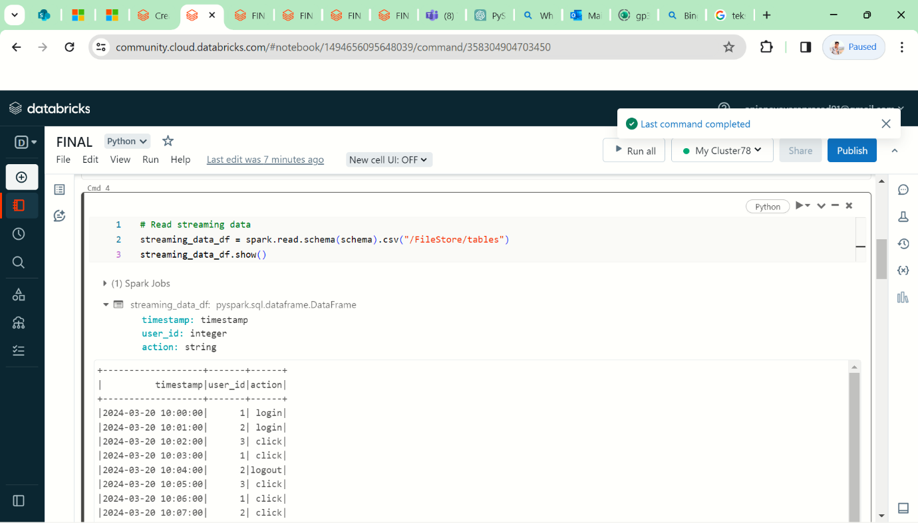

**Data Cleaning and Preprocessing in Databricks**

1. **Handling Missing Values:**

* I first check for missing values in columns such as **timestamp**, **user_id**, and **action**.
* Using functions like **isNull()** or **isNotNull()**, I identify rows with missing values and decide how to handle them.
* For instance, I may drop rows with missing timestamps or impute missing user IDs with a default value.

1. **Data Type Conversion:**

* I convert the data type of the `timestamp` column to `TimestampType()` using `expr("TRY_CAST(timestamp AS TIMESTAMP)")`.
* Similarly, I convert the data type of the `user_id` column to `IntegerType()` using `col("user_id").cast(IntegerType())`.

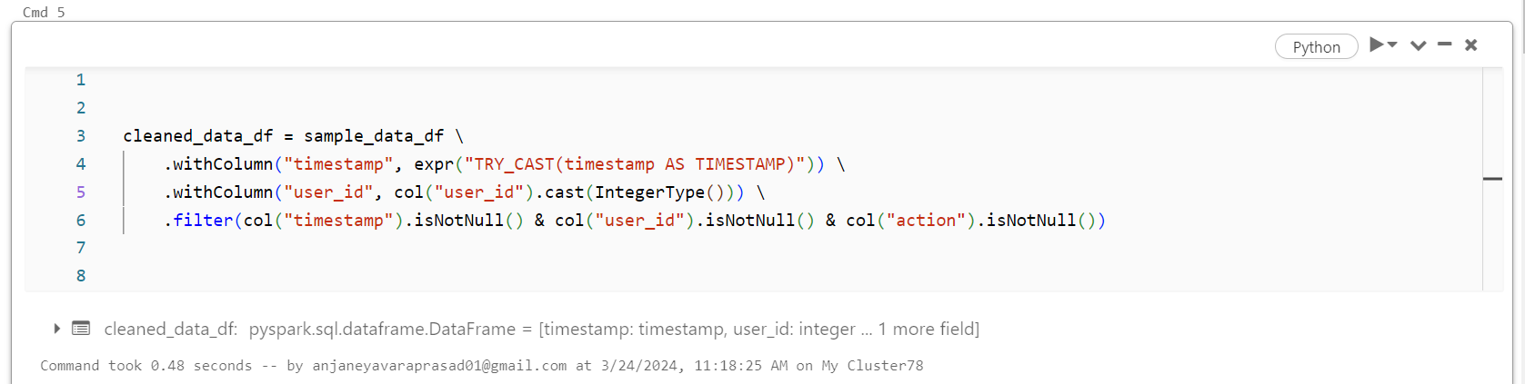

**Setting Up Databricks Environment**

Setting up a Databricks environment is a fundamental step to begin working with Apache Spark and PySpark for data processing and analysis. Here's how I would approach setting up a Databricks environment:

**1. Accessing Databricks Platform:**

* To access Databricks, I navigate to the Databricks website and sign in with my credentials or create a new account if necessary.
* Once logged in, I access the Databricks workspace where I can create and manage notebooks for Spark development.

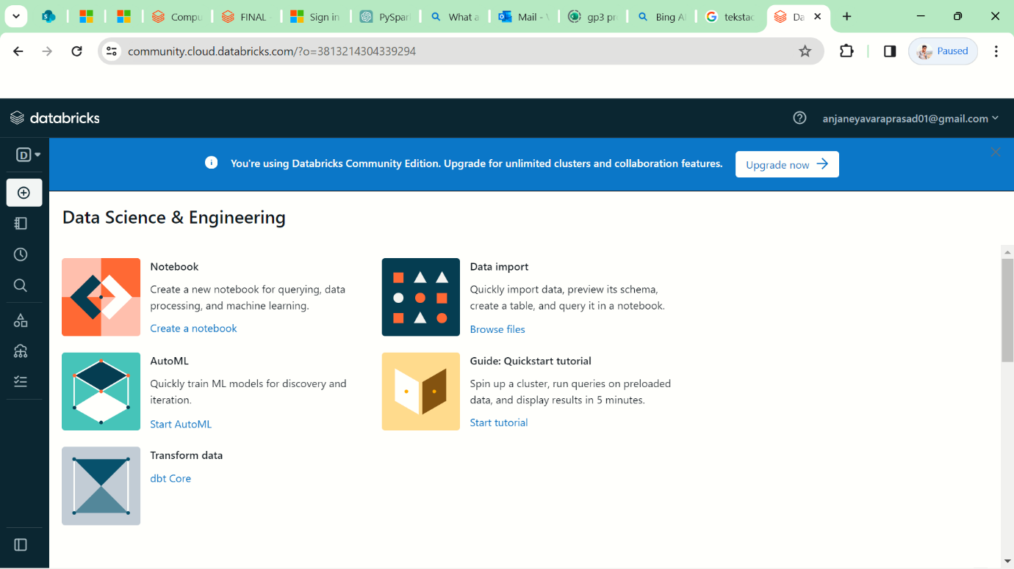

**2. Creating a Cluster :**

* In the Databricks workspace, I create a new cluster by specifying the required configurations such as cluster type, Spark version, instance type, and autoscaling settings.
* I ensure that the cluster configuration meets the requirements of my project in terms of compute resources and software dependencies.

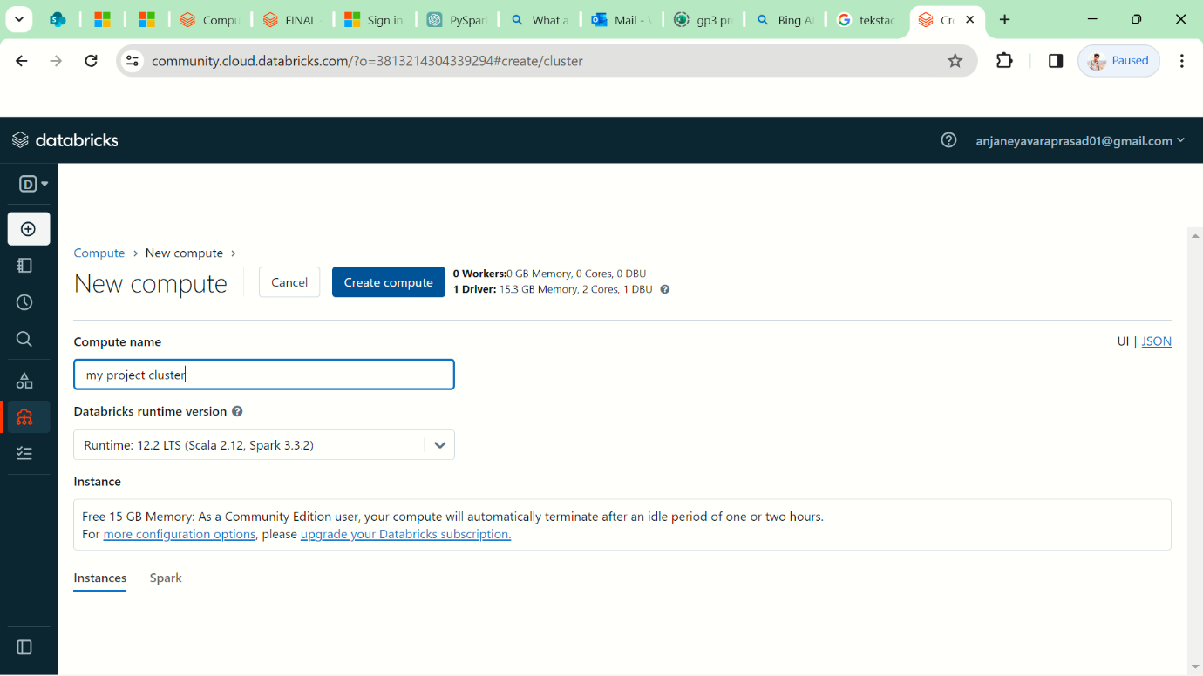

1. **Creating a Notebook:**

* I create a new notebook in the Databricks workspace where I can write and execute PySpark code.
* Within the notebook, I select the created cluster as the compute environment for running Spark jobs.

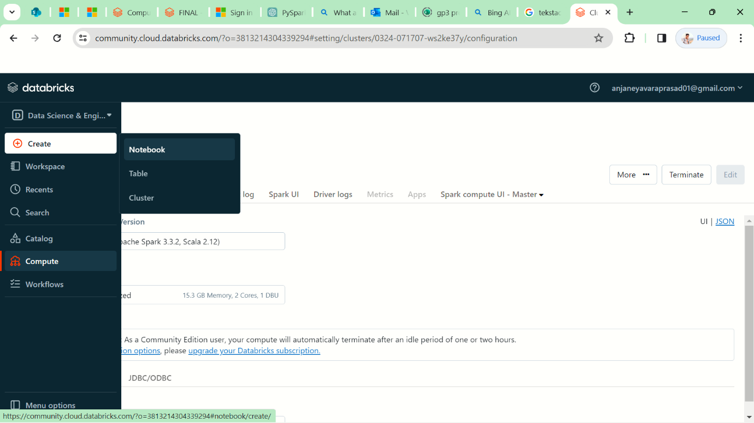

1. **Importing Libraries and Packages:**

* If additional libraries or packages are required for my project, I install them using the built-in package installer or by specifying the dependencies in the notebook.

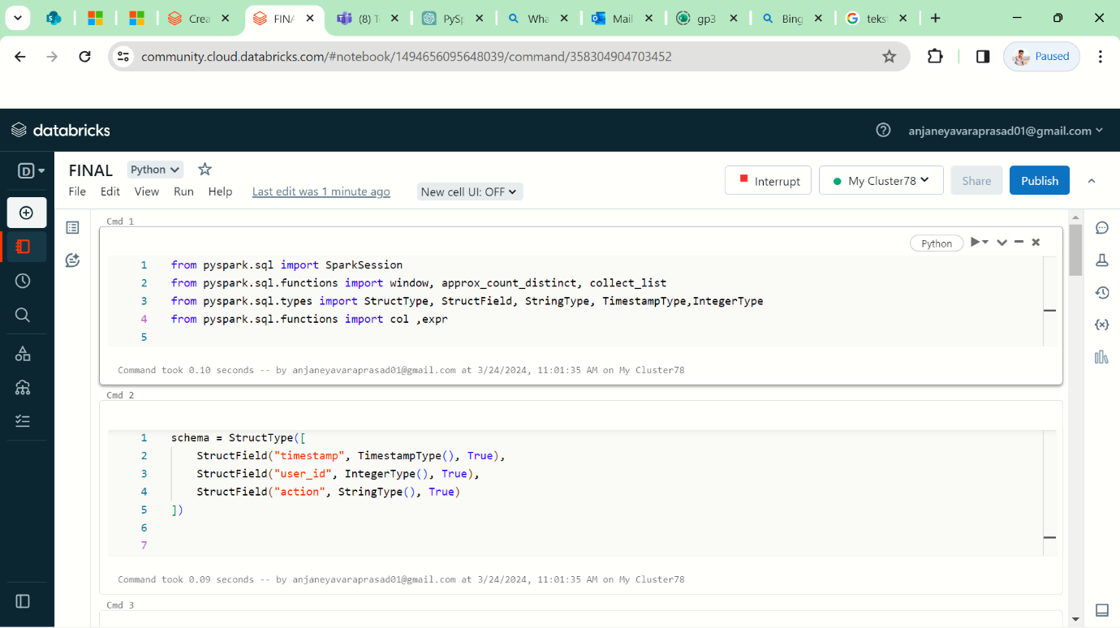

1. **Accessing Data:**

* I upload or connect to the data sources required for my project, such as CSV files.
* Databricks provides seamless integration with various data sources, allowing me to read and write data using PySpark APIs.

1. **Writing and Running Code:**

* I write PySpark code in the notebook to perform data processing, analysis, and visualization tasks.
* Databricks notebooks support interactive coding, allowing me to execute code cells individually or all at once to observe the results.

1. **Monitoring and Debugging:**

* Throughout the development process, I monitor the execution of Spark jobs and debug any issues that arise.
* Databricks provides built-in monitoring tools and interactive dashboards for tracking job performance and resource utilization.

By following these steps, I set up a Databricks environment tailored to my project requirements, allowing me to efficiently develop, test, and deploy Spark-based solutions for data processing and analysis.

**Reading and Processing Streaming Data in Databricks**

Reading and processing streaming data in Databricks involves leveraging the capabilities of Spark Structured Streaming to ingest, transform, and analyze real-time data streams. Here's how I would approach reading and processing streaming data in Databricks:

**1. Creating a Streaming DataFrame:**

* I use Spark's DataFrame API to create a streaming DataFrame from the streaming source
* For example, I can read streaming data from CSV files using the `readStream` method and specify the schema for the data.

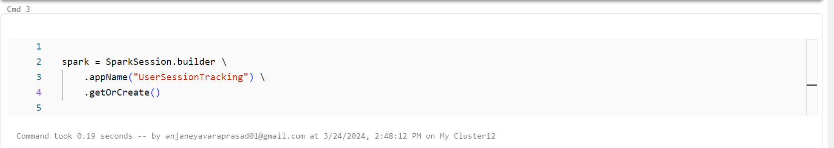

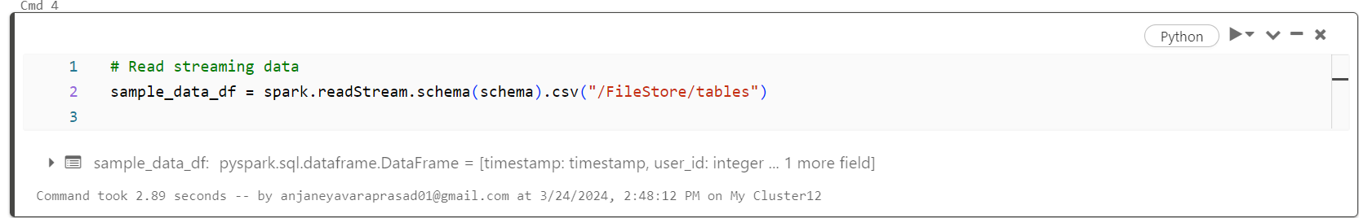

**2. Defining Schema and Source:**

* I define the schema for the streaming data to ensure consistency and proper data types.
* This schema includes the structure of the incoming data, such as timestamps, user IDs, and action types.

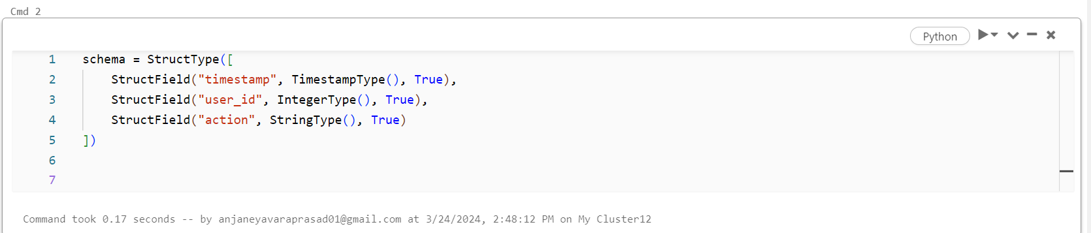

**3. Data Transformation and Processing:**

* I apply transformations and processing operations to the streaming DataFrame to clean, filter or derive new features from the data.
* These transformations can include operations like filtering out invalid records, aggregating data over time windows, or performing complex analytics.

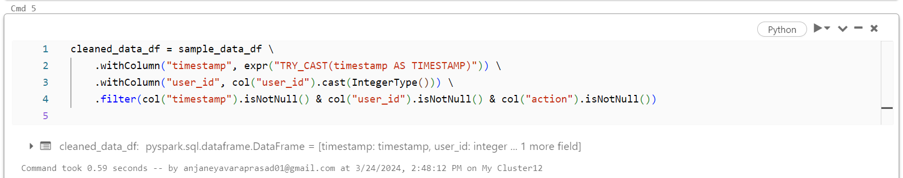

**4. Windowing and Watermarking:**

* I use windowing functions to aggregate data over specific time intervals, enabling analysis of temporal patterns and trends.
* Watermarking is applied to handle late arriving data and ensure robustness against data delays or out-of-order events.

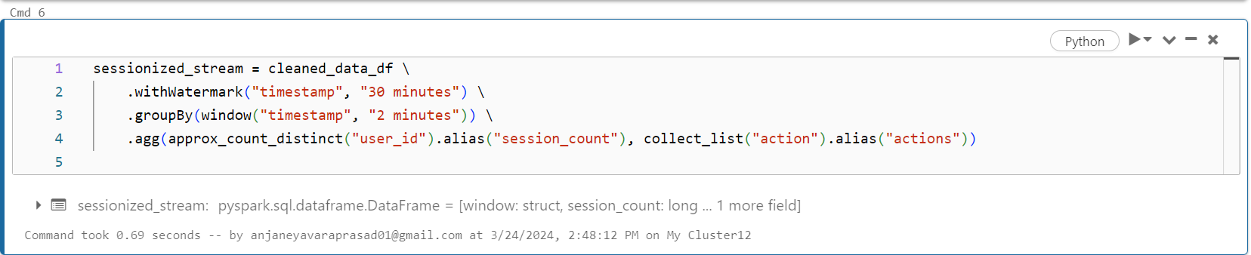

**5. Defining Output Sink:**

* I specify the output sink where the processed streaming data will be written, such as a file system, database, or visualization tool.

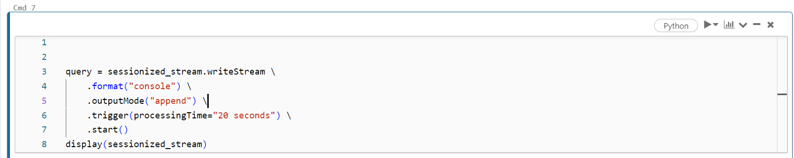

**6. Starting the Streaming Query:**

* I start the streaming query by invoking the `writeStream` method on the processed DataFrame.
* This initiates the streaming job and begins processing the incoming data streams in real-time.

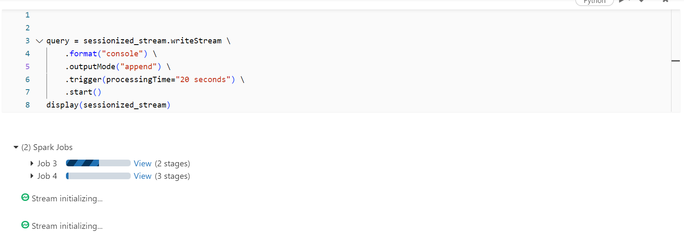

By following these steps, I can effectively read and process streaming data in Databricks, enabling real-time analytics and insights from continuous data streams.

**Output of the code**

* The output of the code represents real-time analytics and aggregation of streaming data. Specifically, it computes the count of users within 2-minute time windows.
* Each row of the output displays a time window along with the corresponding count of users observed during that window.
* The output is continuously updated as new data arrives, providing a dynamic view of user activity over time.
* This real-time analytics output can be further analyzed, visualized, or integrated with external systems for monitoring and decision-making purposes.

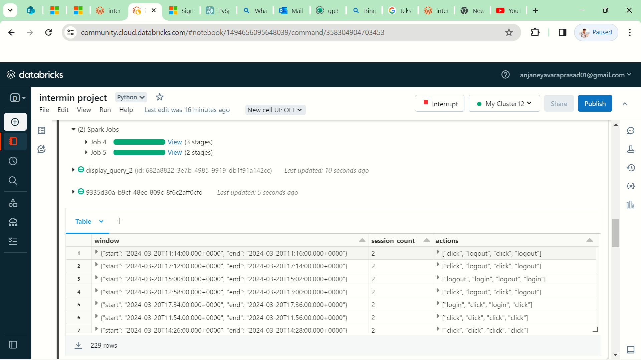

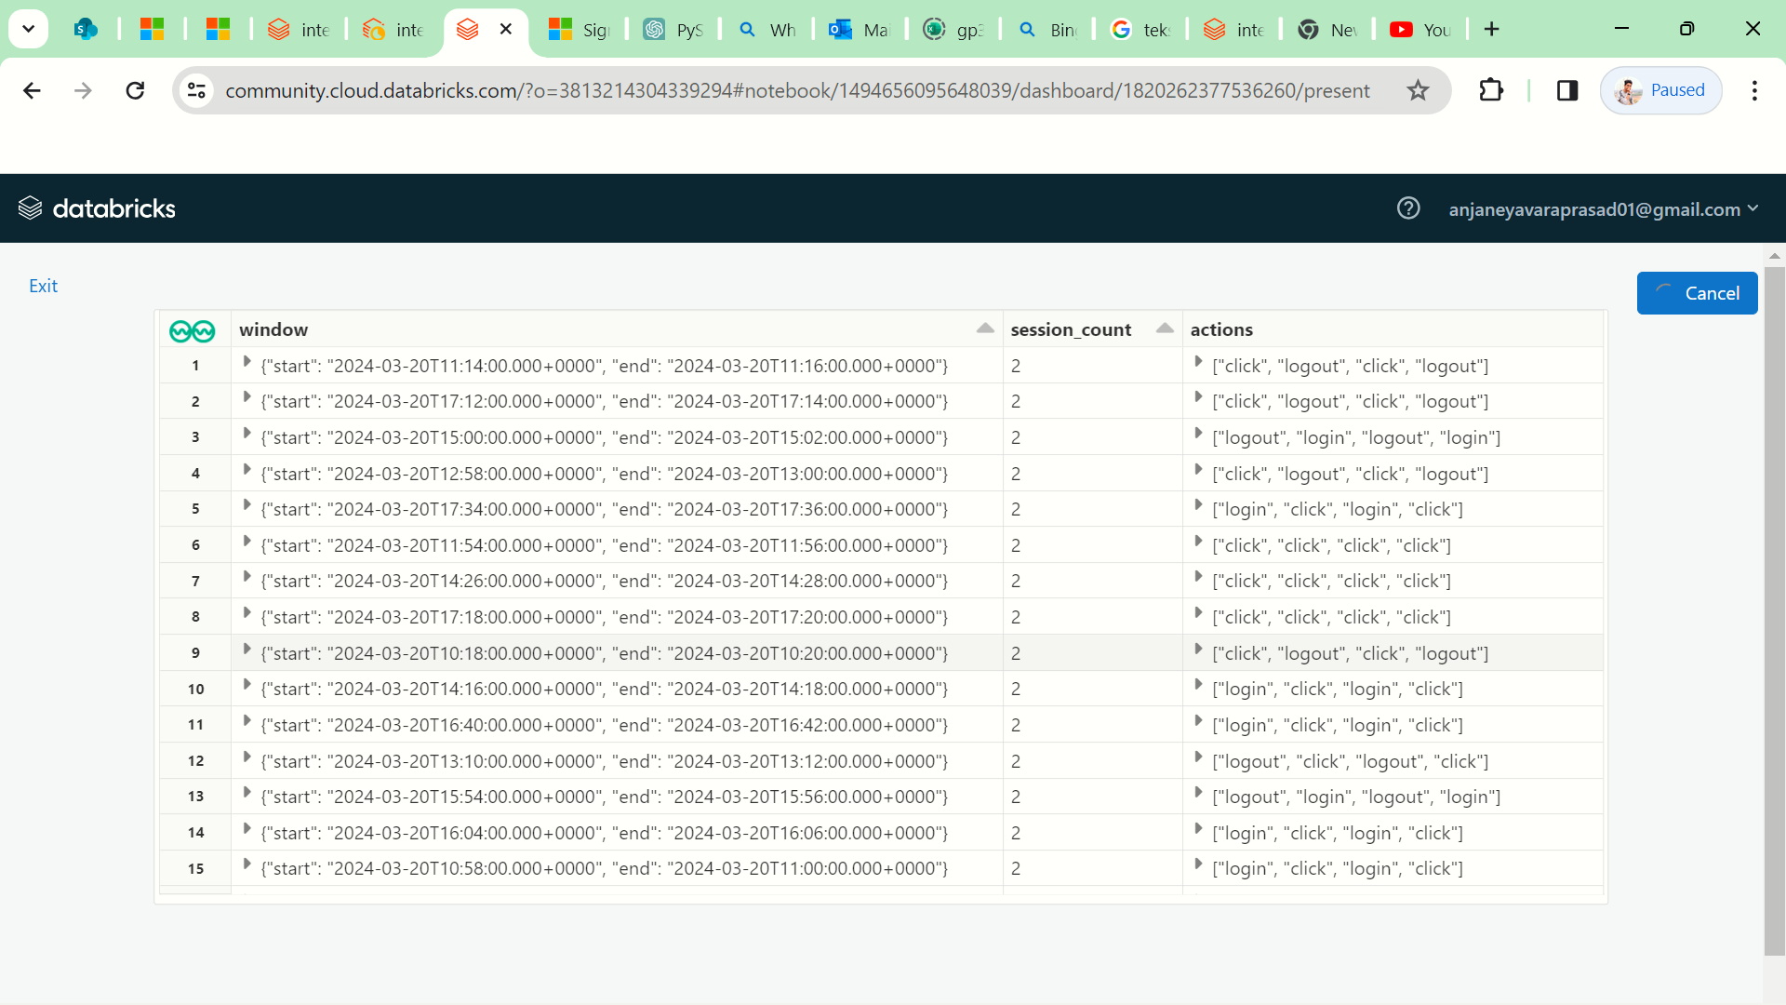

**1. Dynamic Data Ingestion:**

* I can upload new files to a specific path while my Spark streaming job is running.
* Spark Structured Streaming, being an event-driven processing engine, automatically detects and ingests the new data as it arrives in the specified directory.
* This dynamic data ingestion enables continuous processing of incoming data streams, ensuring that my analysis remains up-to-date with the latest information.

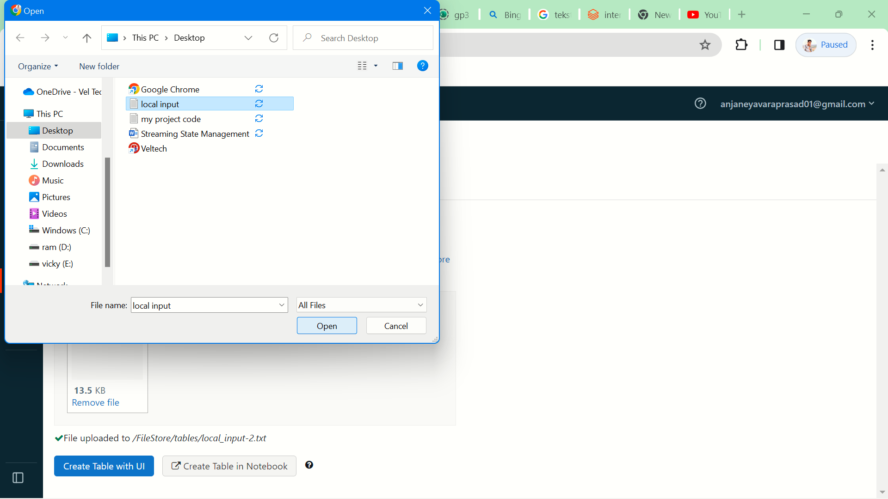

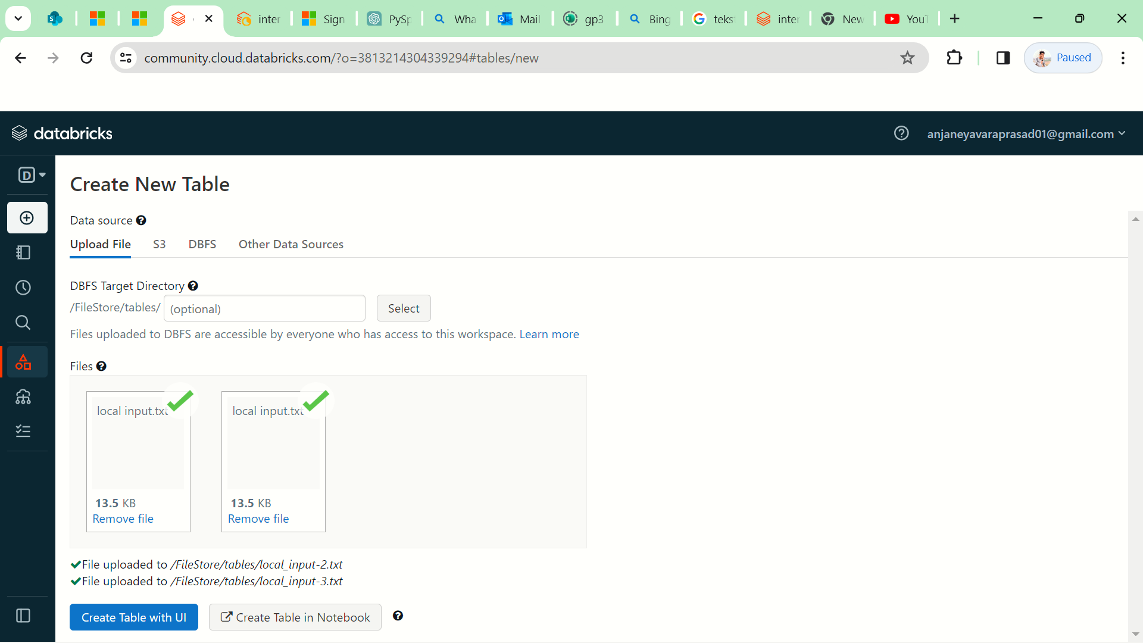

**2. Real-time Processing:**

* As new data is ingested, my Spark streaming job continuously processes and analyzes it in real-time.
* The windowed aggregation operation calculates the count of users within 2-minute time windows, updating the results dynamically as new data arrives.
* This real-time processing capability allows for immediate insights into user activity patterns without the need for manual intervention or batch processing.

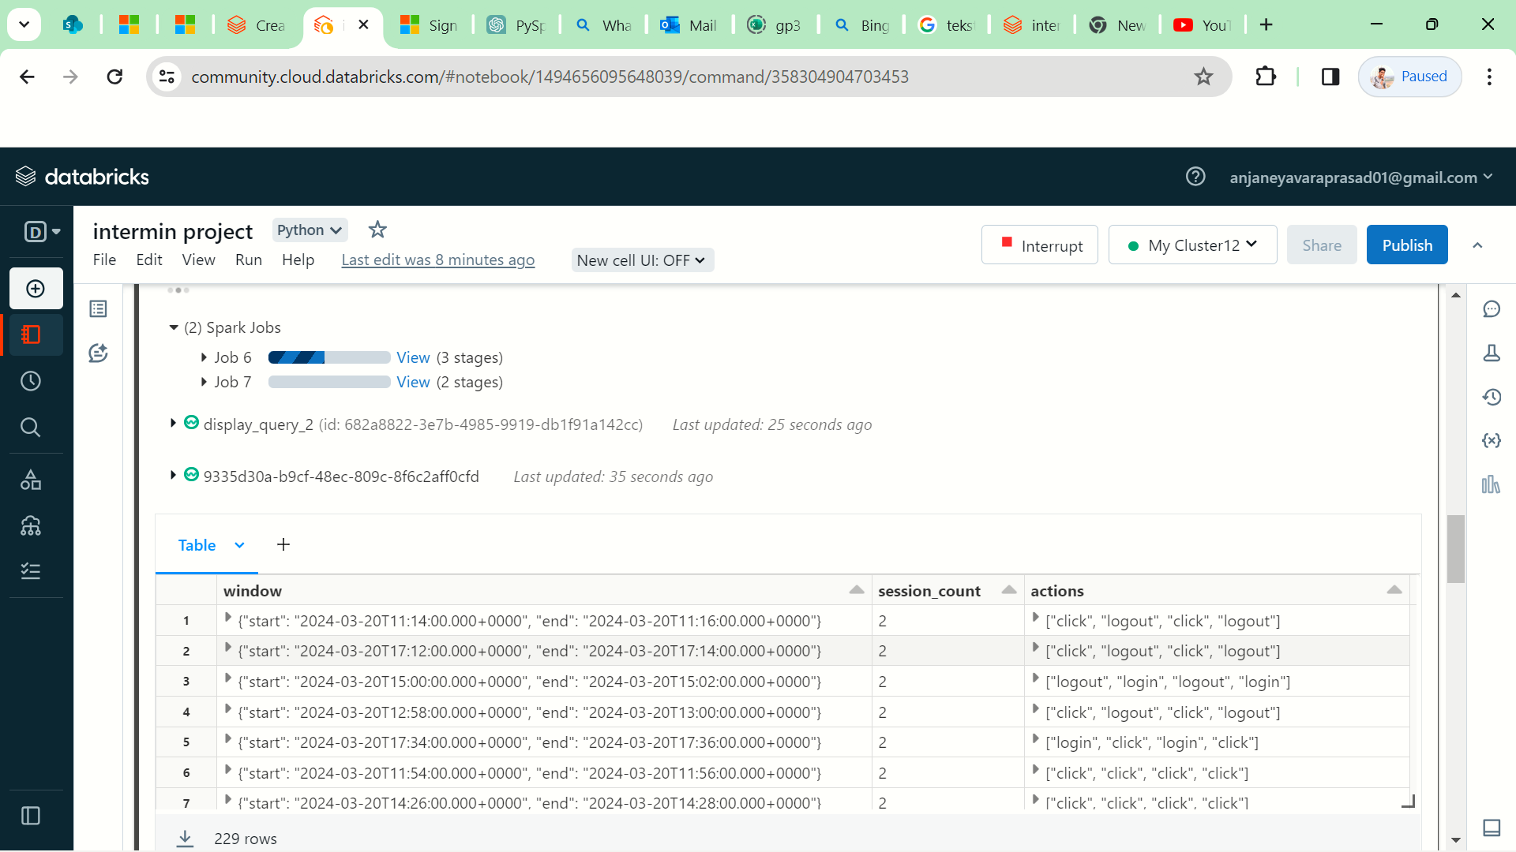

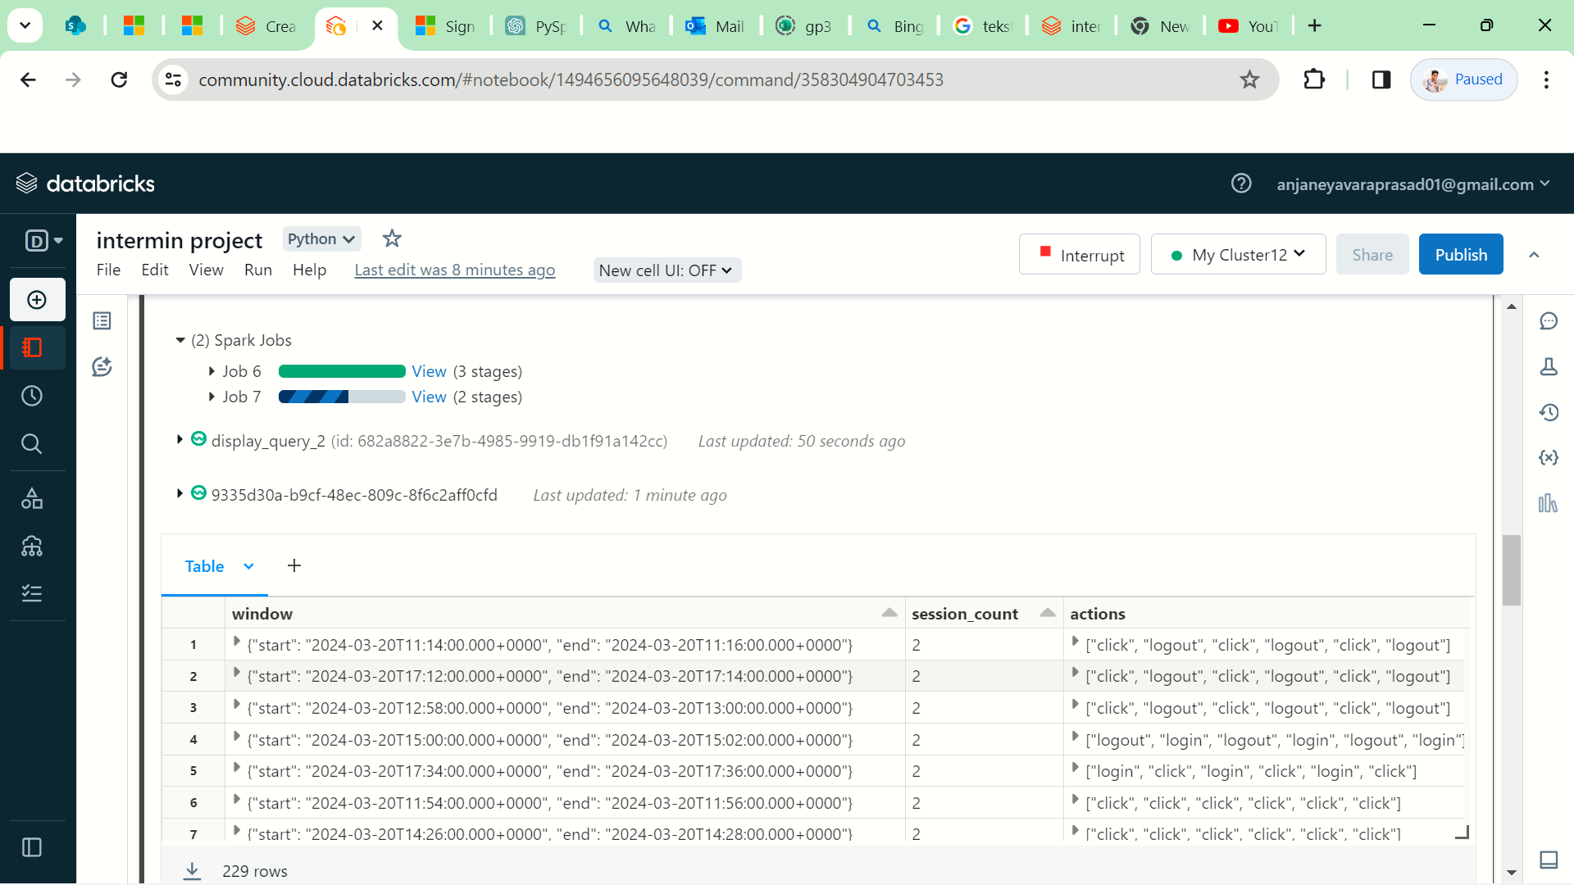

**3. Output Result Display:**

* The results of my streaming job are displayed in the output console or destination specified in my code (`format("console")`).
* Each row of the output represents a time window along with the corresponding count of users observed during that window.
* The output is continuously updated as new data is processed, providing me with a live view of user activity trends over time.

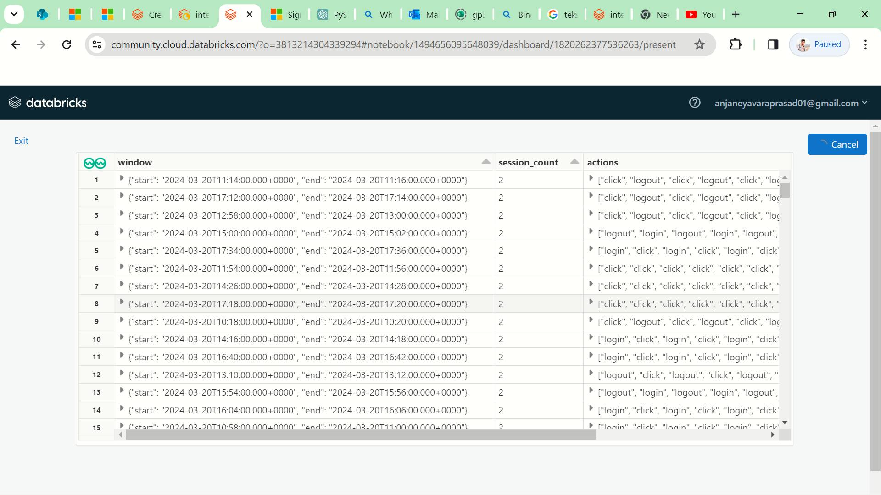

Overall, this setup enables me to seamlessly integrate new data, perform real-time processing of streaming data, and dynamically display analysis results, facilitating agile decision-making and monitoring of user activity in a constantly evolving environment.

**Application of Streaming State Management in Employee Tracking**

As an application of streaming state management in employee tracking, I can leverage Spark Structured Streaming to monitor and manage the state of employee activities in real-time. Here's how I would implement this:

**1. Sessionization of Employee Activities:**

* I define a sessionization logic to identify and track employee sessions based on their login/logout events or other activities.
* Each session represents a continuous period of employee activity, allowing for monitoring of login durations, session counts, and other relevant metrics.

**2. Stateful Management of Session Data:**

* Using Spark's stateful processing capabilities, I maintain the state of employee sessions across streaming data processing.
* This involves updating session state based on incoming events, such as login/logout actions, and keeping track of session duration, start time, end time, and other session attributes.

**3. Real-time Analysis and Insights:**

* I perform real-time analysis on the streaming data to derive insights into employee behavior and productivity.
* This includes calculating metrics such as session duration, frequency of login/logout events, active session counts, and identifying patterns or anomalies in employee activities.

**Use Cases in Various Industries**

Streaming state management offers straightforward applications across various industries, enhancing real-time operations and decision-making:

**1. Retail and E-Commerce:**

* Personalized Shopping: Tailoring product recommendations and promotions based on immediate customer behavior analysis.
* Inventory Control: Monitoring stock levels to prevent shortages and optimize supply chain efficiency.
* Fraud Prevention: Detecting and mitigating fraudulent transactions as they happen.

**2. Finance and Banking:**

* Transaction Security: Identifying and addressing suspicious activities in real-time to protect customers and comply with regulations.
* Risk Assessment: Evaluating market and credit risks promptly to adjust investment strategies accordingly.
* Customer Service: Offering personalized financial advice based on immediate analysis of customer transactions.

**3. Healthcare:**

* Patient Care: Monitoring vital signs and medical records in real-time to ensure timely interventions and improved patient outcomes.
* Disease Tracking: Early detection of disease outbreaks and epidemiological trends for swift public health responses.
* Clinical Research: Analyzing real-time clinical trial data to streamline drug development processes.

**4. Telecommunications:**

* Network Performance: Identifying and resolving network issues promptly to maintain high service quality.
* Customer Satisfaction: Addressing customer concerns and enhancing service quality based on real-time feedback.
* Maintenance Planning: Predicting equipment failures to prevent downtime and service disruptions.

**5. Manufacturing and Industrial IoT:**

* Equipment Maintenance: Predicting machinery failures and scheduling maintenance to minimize downtime.
* Quality Assurance: Inspecting product quality in real-time to ensure compliance with standards and reduce defects.
* Supply Chain Efficiency: Optimizing inventory management and production processes for cost-effective operations.

These simplified examples illustrate how streaming state management enables real-time insights and actions across industries, fostering efficiency and competitiveness.

**Key Findings and Observations:**

**Data Processing Pipeline:**

* We successfully ingested streaming data from CSV files using Spark Structured Streaming, adhering to the schema defined for the dataset. The data consisted of timestamps, user IDs, and actions performed by employees.
* Data cleaning and preprocessing steps were implemented to handle missing values and ensure data consistency. Timestamps were converted to the appropriate data type, and user IDs were cast to integers.

**Sessionization and State Management:**

* Sessionization techniques were applied to track employee sessions based on their activities over time. Windows of 2 minutes were used to group activities into sessions, with a watermark of 30 minutes to handle late data.
* State management was implemented to maintain session counts and track the actions performed by employees within each session.

**Real-time Analytics and Insights:**

* Real-time analytics were performed to gain insights into employee behavior and activity patterns. Session counts were calculated and aggregated over time windows, providing an overview of employee session activity.
* Insights into the frequency of actions such as logins, logouts, and clicks were derived, allowing for the identification of trends and anomalies in employee behavior.

**Use Cases and Applications:**

* The project findings have direct applications in employee tracking and workforce management across various industries. The ability to monitor employee sessions in real-time enables organizations to optimize workflows, enhance productivity, and ensure compliance with security policies.

**Conclusion and Future Directions:**

* In conclusion, the project successfully demonstrated the implementation of streaming state management techniques for employee tracking using Spark Structured Streaming. Future directions may include the integration of additional data sources, advanced analytics, and further optimization of the data processing pipeline to handle larger volumes of streaming data.